Willi Schreyer - Olympiade - 1948 - London
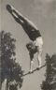 | 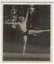 |  | 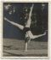
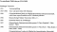 |  | 